YEAR 11



MOCK 1 Revision

AQA English Language Papers 1 & 2
AQA English Literature Paper 1

Name: ______________________________________
Class: ______________________________________
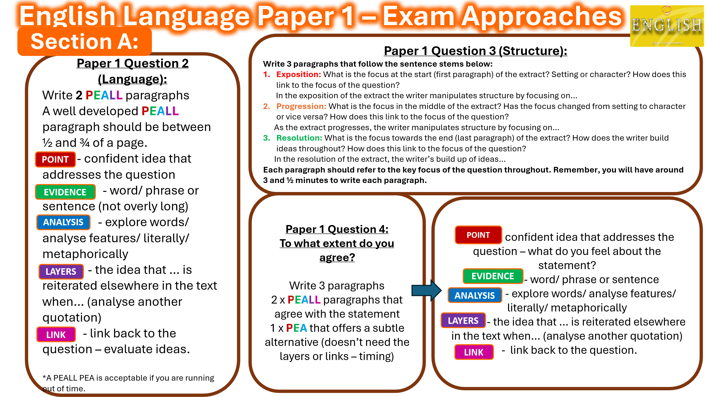

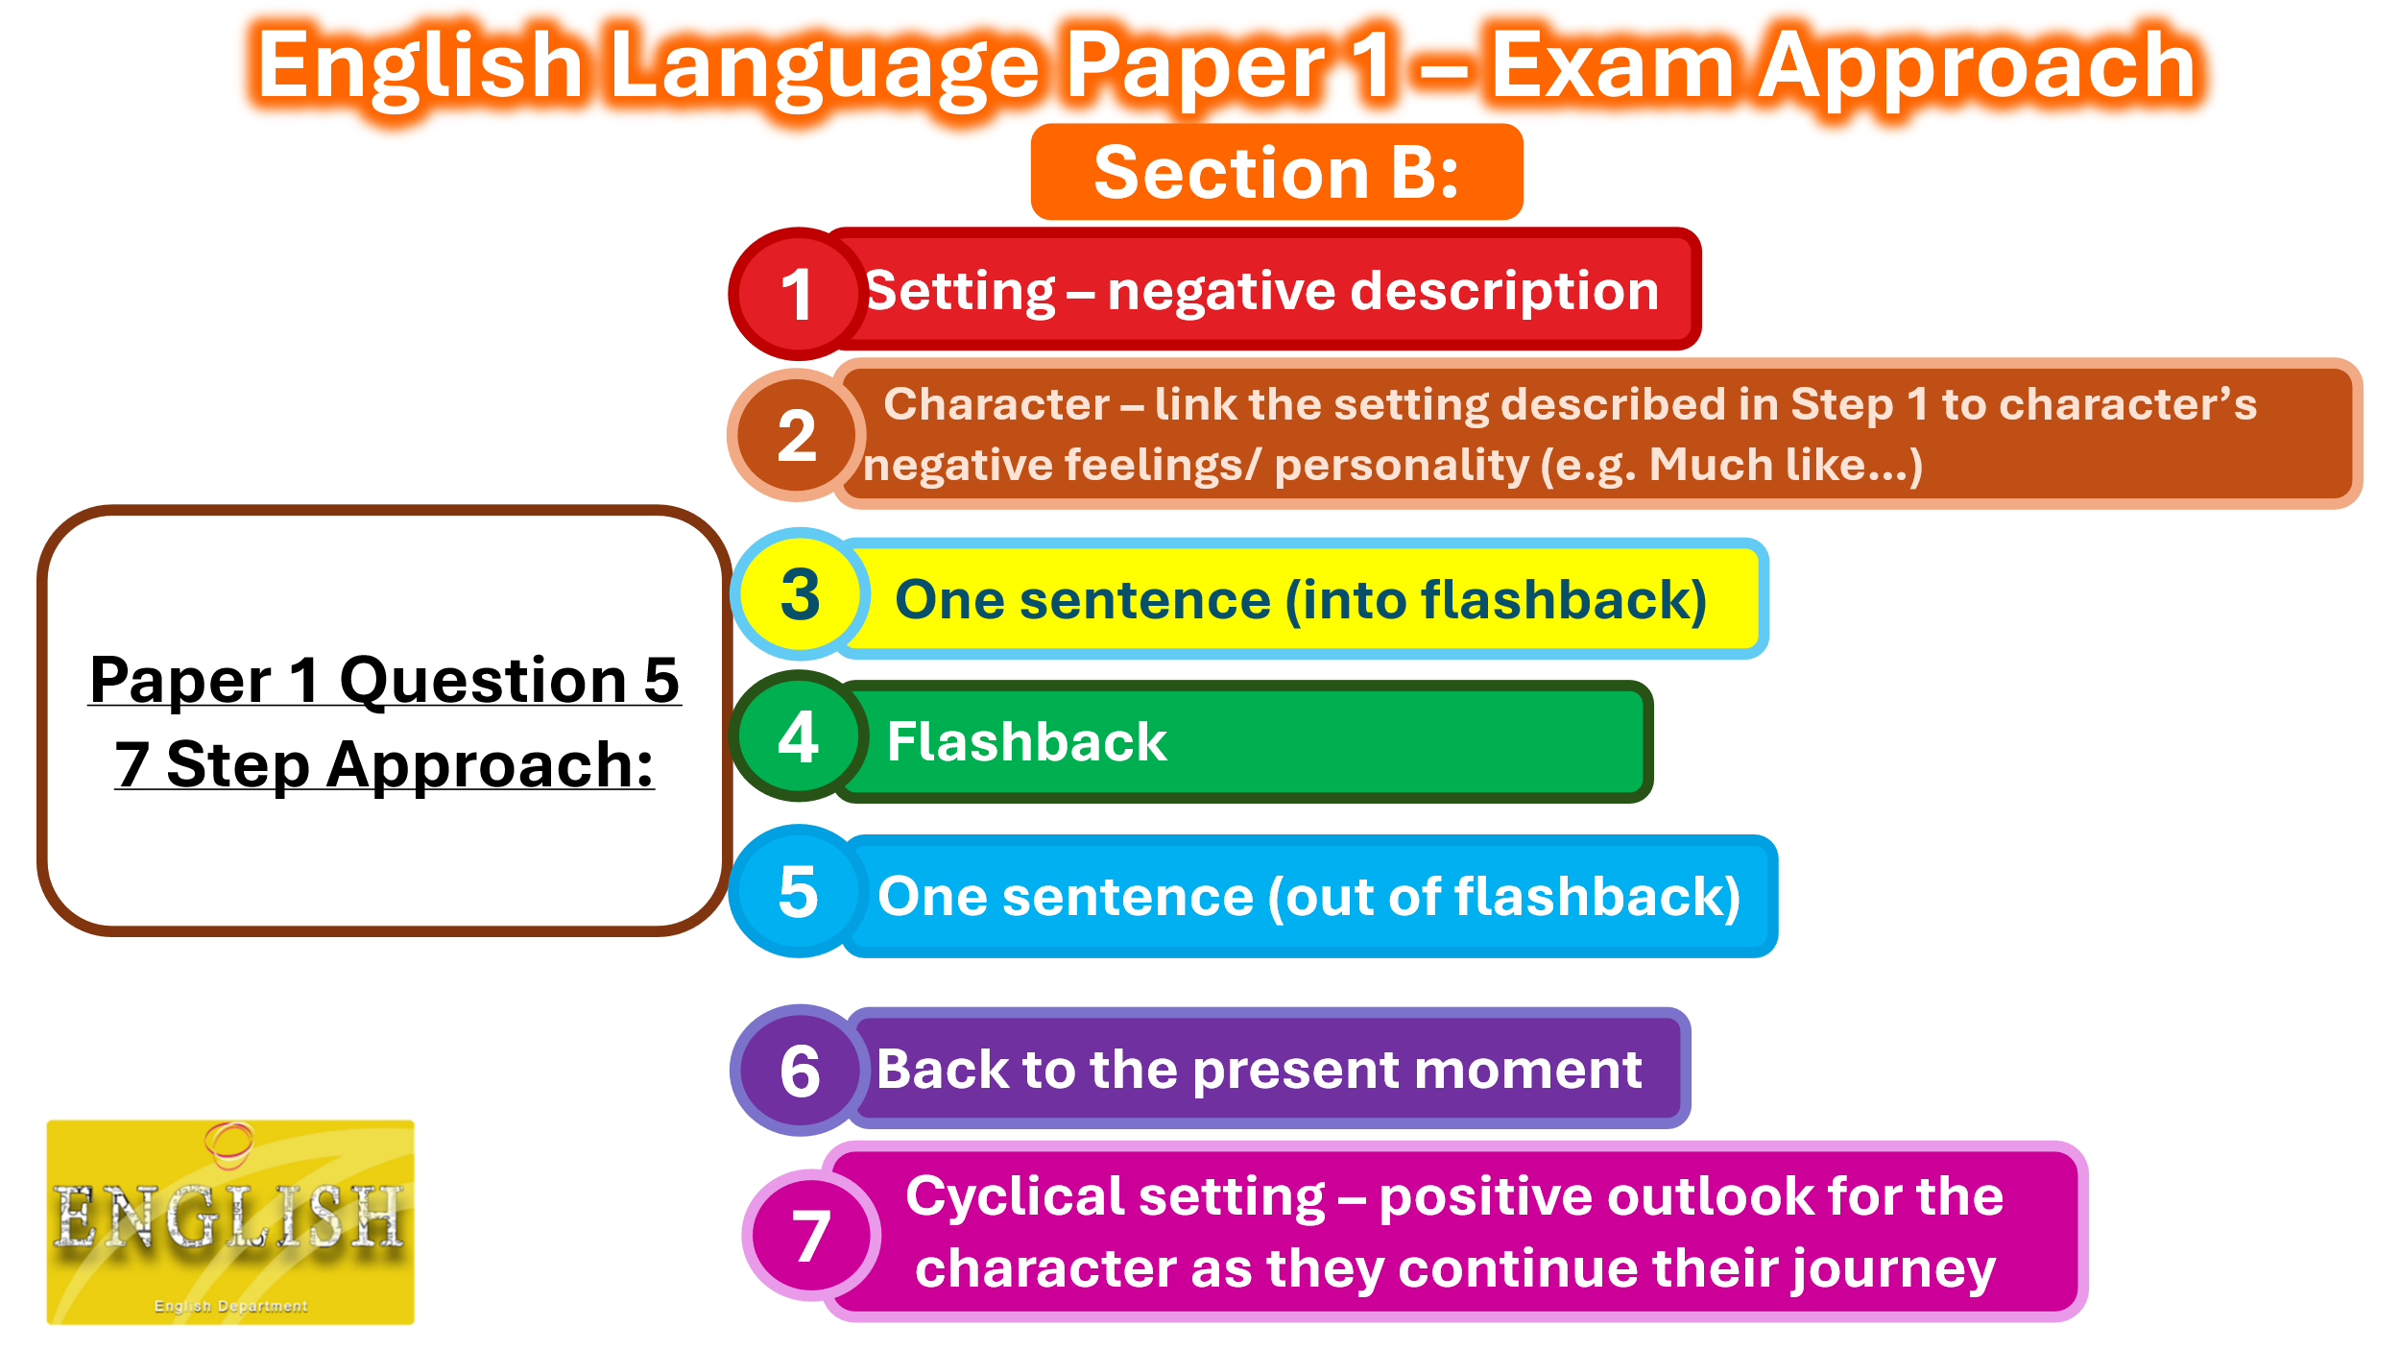

Language Paper 1 Practice
Mini Extract: The Murder on the Train
It is very late and the train is quiet. There are only four passengers in the carriage. The first is a young man in a smart but cheaply made suit. He has just been to his first job interview and is nervously and repeatedly checking his mobile phone.
The second passenger is a middle aged woman with greying hair. She is propped up against a window fast asleep. She has three jobs at the moment, and together they just about pay the bills, but she spends her life in a constant state of exhaustion.
The final two passengers are a retired couple, who have just been to visit their young grandchildren. The woman is feeling glad that she and her husband live over an hour away, and aren’t asked to babysit more often. She had forgotten how exhausting babies were. Her husband had been thinking something similar, but is now wondering if the weather will be good enough for a round of golf tomorrow.
None of the passengers in the carriage take much notice of one another. None of the passengers in the carriage are aware that a murder has been committed on their train, and that by the time they pull in at their destination, they will all be suspects.

Question 1: Multiple choice
1.1 How has the train been described?
A) Quiet
B) Loud
C) Noisy
1.2 What does the man keep checking?
A) Wallet
B) Time
C) Phone
1.3 How far away do the retired couple live?
A) 30 minutes
B) 1 hour
C) 2 hours
1.4 What has been committed on the train?
A) Murder
B) Theft
C) Stabbing
Question 2: How does the writer use language to describe the different passengers?
Question 3: How does the writer use structure to create suspense?
Question 4: It is surprising that we find out there is a murderer on the train as the other passengers seem to be pretty normal.
To what extent do you agree or disagree with the statement?
Question 5: NARRATE OR DESCRIBE
A website has asked for examples of creative writing for its new page.
EITHER: Write a description of an intimate family gathering. You may choose to use the picture provided for ideas.
OR: Write the opening of a story based around friendship.


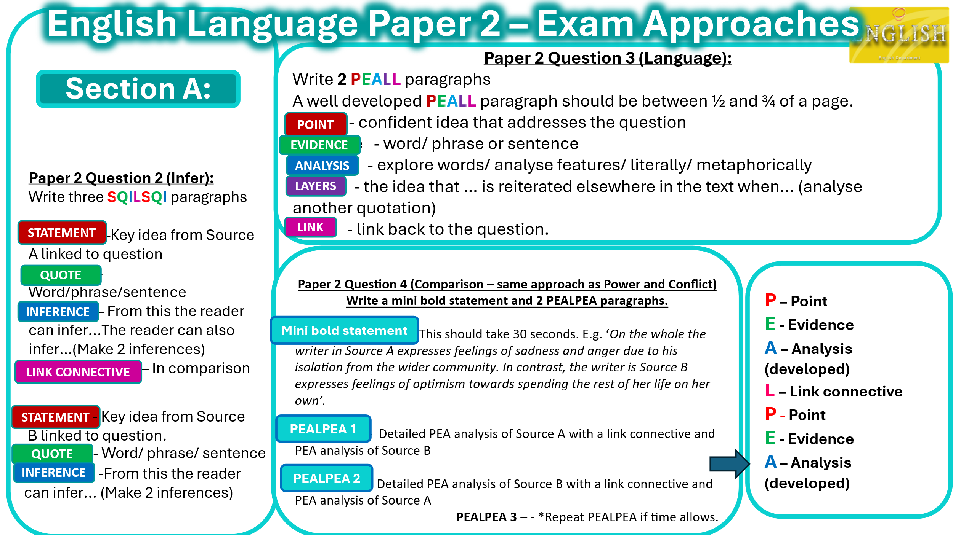

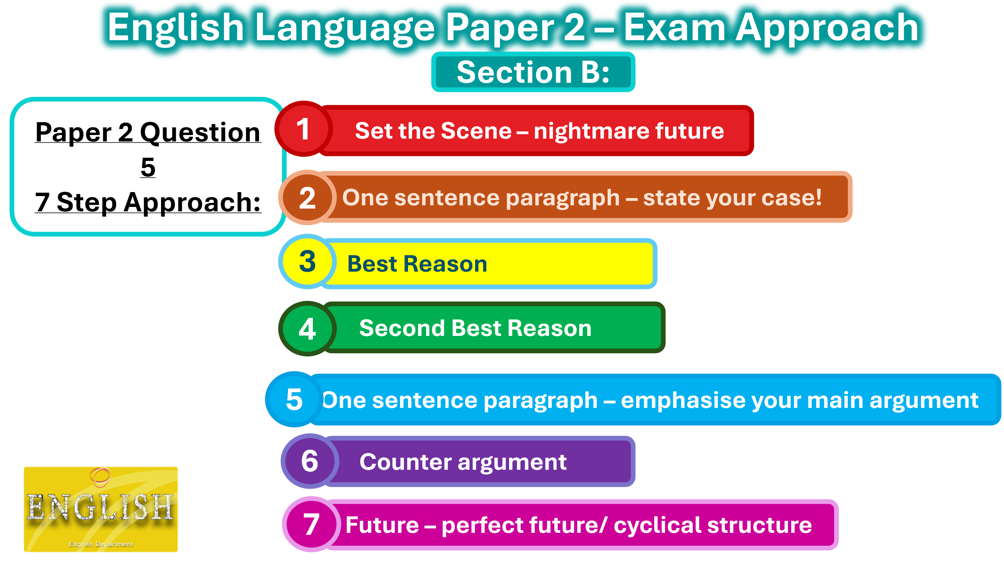

Language Paper 2 Practice
Source A: Extract from The Girl of the Period by Eliza Lynn Linton (1883). She was in her 60s when she wrote this about the women of her day.
The liberty allowed to young girls grows yearly more and more unchecked. They walk alone, travel alone, visit alone; and the gravest of evils have been known to arise from the habit which modern mothers have of sending their daughters of sixteen and upwards unaccompanied in London to colleges and classes. Mamma has grown stout and lazy, and has always some important matter on hand that keeps her at home, half asleep in the easy-chair, while the girls go to and fro, and take the exercise befitting their youthful energies. Of course no harm can befall them. They are her daughters, and the warnings given by the keener-eyed, who have had no experience, are mere inventions of the enemy and slanders against the young. So they parade the streets, dressed in the most startling and meretricious* costumes; and that fatal doctrine of self-protection counts its victims by the score as the consequence.
*meretricious – superficially attractive but actually worthless, vulgar or flashy

Source B: A letter to The Times newspaper in which 16-year-old Jenni Herd responds to an article about teenagers.
I am getting increasingly annoyed at the barrage of articles about teenagers, and the adults who keep trying to explain our behaviour (“Moods and meltdowns: what’s inside the teenage brain?”, Mar 1).
I am 16 and a straight-A student, like most of my friends. We are not as irrational and immature as adults seem to think. We’ve grown up with financial crises and accept that most of us will be unemployed. We no longer flinch at bloody images of war because we’ve grown up seeing the chaos in the Middle East and elsewhere. Most of us are cynical and pessimistic because of the environment we’ve grown up in — which should be explanation enough for our apparent insolence and disrespect, without “experts” having to write articles about it.
Has no one ever seen that we are angry at the world we live in? Angry that we will have to clean up your mess, while you hold us in contempt, analysing our responses as though we were another species?
I would like adults to treat us not as strange creatures from another world but as human beings with intelligent thought — a little different from yours, perhaps, but intelligent thought nonetheless.
Stop teaching adults how to behave around us, and instead teach them to respect us.

Question 2: What can you infer about the writer’s different beliefs about young people?
Question 3: In Source A, how does the writer use language to show how annoyed they are?
Question 4: Compare how the two writers convey their attitudes towards young people.
Question 5: ‘Modern Music glorifies violent and criminal lifestyle and should be banned.’
Write a speech to be delivered in your school assembly, in which you explain your point of view on this statement.

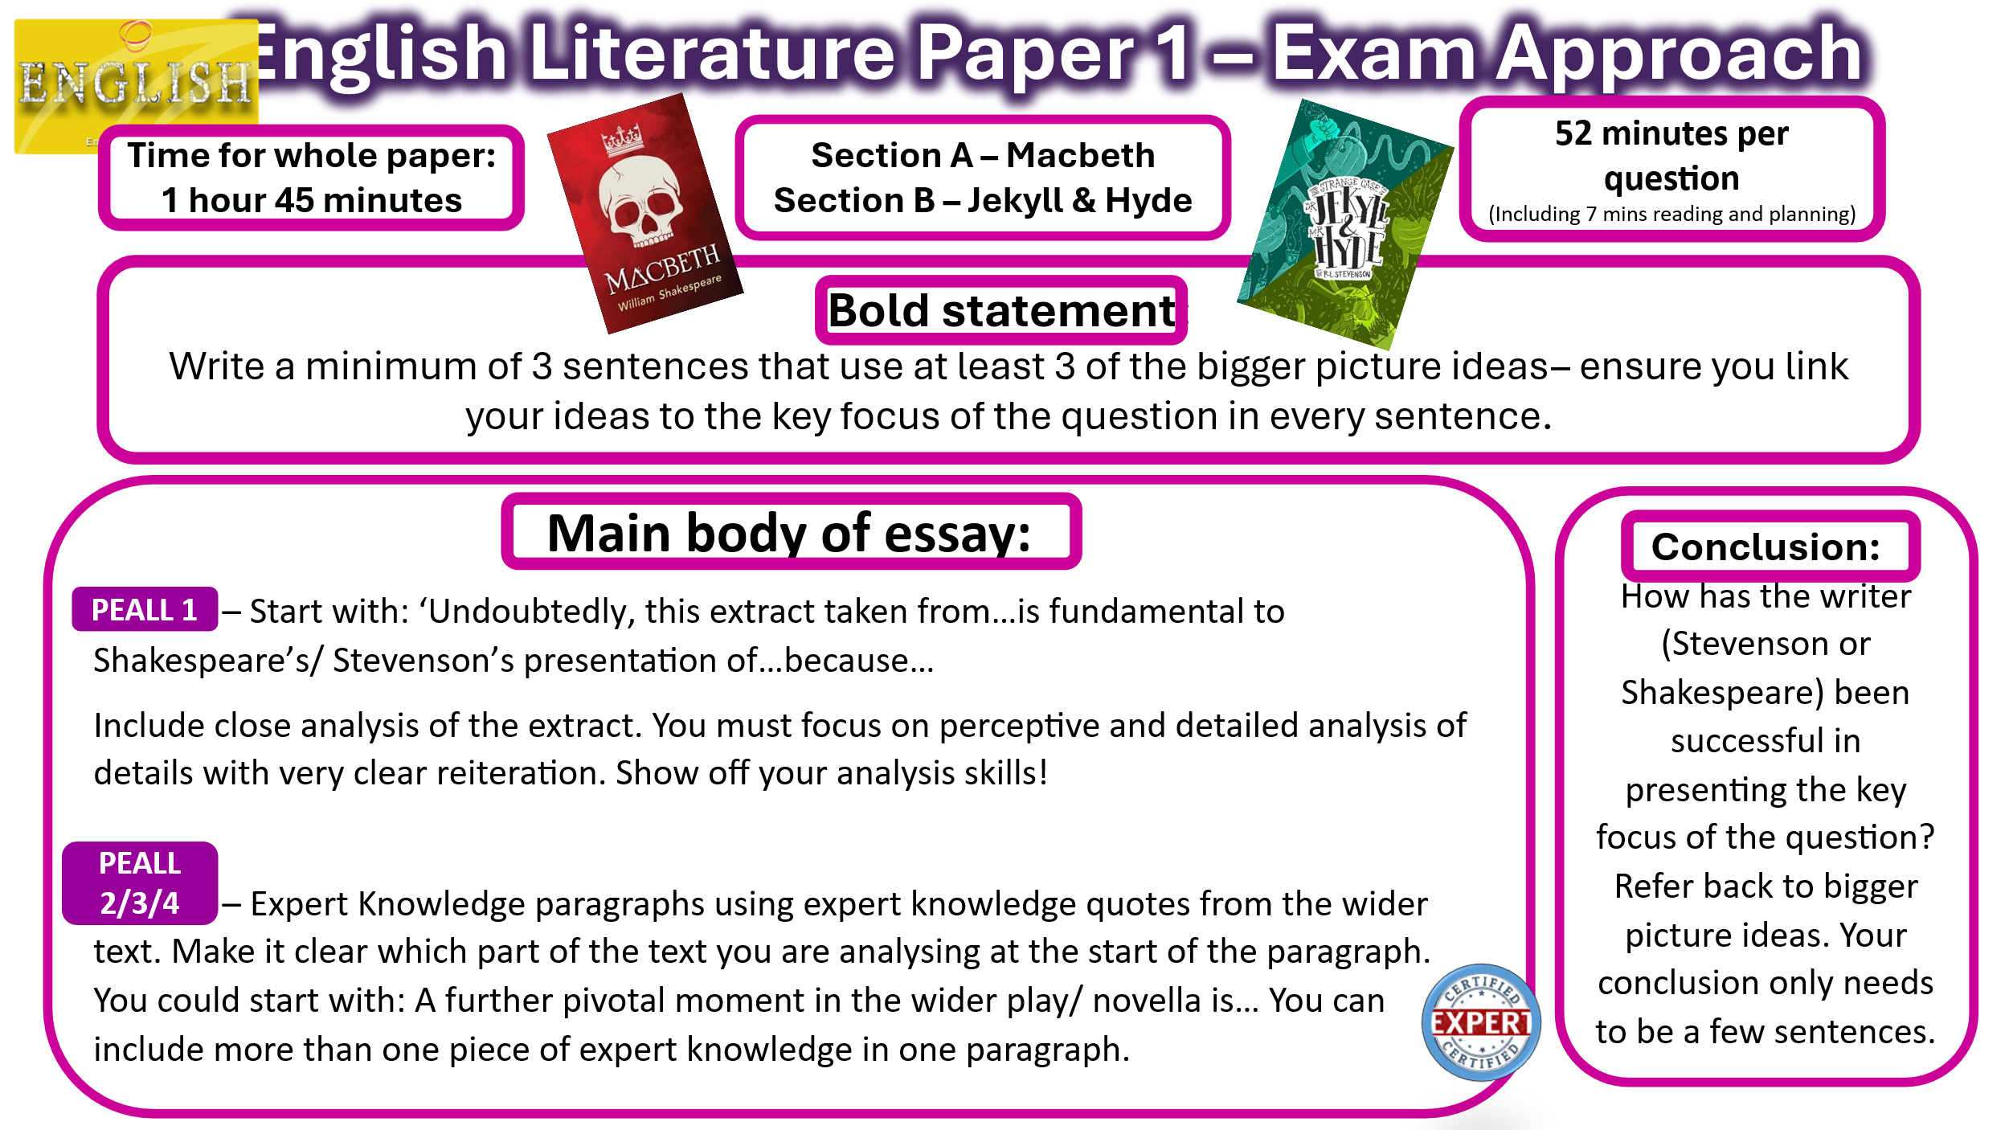

The Strange Case of Dr Jekyll and Mr Hyde: Characters and Themes
Dr Henry Jekyll
- Key themes: duality, repression, science, reputation, good vs evil
Mr Edward Hyde
- Key themes: evil, violence, duality, repression
Mr Gabriel John Utterson
- Key themes: reputation, secrecy, friendship, Victorian society
Dr Hastie Lanyon
- Key themes: science, reason, supernatural, secrecy
Mr Enfield
Poole
Sir Danvers Carew

Themes:
- Duality of human nature
- Good vs evil
- Reputation and respectability
- Secrecy
- Repression
- Science and experimentation
- Religion and morality
- Violence
- Fear and the unknown
- Victorian society
- Friendship
- Appearance vs reality

Macbeth: Characters and Themes
Macbeth
- Key themes: ambition, guilt, violence, kingship, the supernatural
Lady Macbeth
- Key themes: ambition, guilt, gender, power, the supernatural
The Three Witches
- Key themes: supernatural, fate, ambition, appearance vs reality
Banquo
- Key themes: fate, loyalty, ambition, morality
Macduff
- Key themes: loyalty, revenge, masculinity, good vs evil
King Duncan
- Key themes: kingship, loyalty, betrayal, order vs disorder
Malcolm
Fleance
Donalbain

Themes:
- Ambition
- Power
- Guilt and conscience
- The supernatural
- Kingship and leadership
- Fate vs free will
- Violence
- Good vs evil
- Masculinity and femininity
- Loyalty and betrayal
- Appearance vs reality
- Order vs disorder

Act 1 |  | Act 1 Scenes 1-3  The witches create an unsettling exposition by claiming that ‘fair is foul and foul is fair’. We hear about the heroic and ‘brave’ Macbeth’s decisive action during the war and how his sword ‘smoked with bloody execution’. The witches then reveal three prophecies including ‘All hail Macbeth, that shalt be King hereafter’. | “…Till that Bellona's bridegroom, lapped in proof..."  “Look like the innocent flower but be the serpent under’t”  “Disdaining fortune, with his brandish'd steel,”  “…or memorise another Golgotha”  “In a sieve I'll thither sail, And, like a rat without a tail, I’ll do, I’ll do, and I’ll do.”
 |  | Act 1 Scenes 4-7  Ominously, the first two prophecies come true as Macbeth is awarded the title ‘Thane of Cawdor’. We then meet Lady Macbeth whose soliloquy reveals her to be ruthless as she asks the spirits to ‘unsex me here’. She then reveals her cunning by telling the doubtful Macbeth ‘Look like the innocent flower but be the serpent under’t’. | “Come, thick night, And pall thee in the dunnest smoke of hell”  “Heaven’s Cherubim”  “Letting 'I dare not' wait upon 'I would,’ Like the poor cat i' the adage?”  “He has almost supped.”
Act  2 |  | Act 2 Scenes 1-2  Macbeth appears to hallucinate and asks, ‘is this a dagger I see before me?’ before killing Duncan off-stage. Lady Macbeth commands him to ‘give me the daggers’ as he forgets to leave them behind. Macbeth asks, ‘will all Neptune’s ocean wash this blood clean from my hand?’ which symbolises his guilt. | “…with Tarquin’s ravishing strides”  “Pluck out mine eyes”
 |  | Act 2 Scenes 3-4  The Porter appears and imagines he is the porter of ‘hell-gate’ and symbolises how Duncan’s murder has unleashed evil. Macduff pronounces ‘horror, horror, horror’ upon discovering Duncan’s body. The old man ominous claims to have seen ‘dreadful and things strange’. | “destroy your sight With a new Gorgon”  A falcon …was by a mousing owl hawked at and killed.  “Great doom’s image”  “both the scales”
Act  3 |  | Act 3 Scenes 1-3  Macbeth begins to see Banquo as a threat and claims that he has a ‘fruitless crown’. The throne has not bought hi any happiness and he claims ‘O, full of scorpions is my mind’. After Banquo is murdered but Fleance escapes, Macbeth hosts a banquet but soon begins to hallucinate again and tells Banquo’s ghost, ‘Never shake thy gory locks at me’ | “…under him my genius is rebuked, as it is said Mark Antony's was by Caesar...”
 |  | Act 3 Scenes 4-6  Hecate and the witches refer to Macbeth as a ‘wayward son’. Lennox and a Lord speak of their ‘suffering country’ and what has become of it and also about how the murder of Banquo has been blamed officially on his son Fleance. The men call Macbeth a ‘tyrant’ for the first time. | “…all you have done Hath been but for a wayward son…”  “And at the pit of Acheron  Meet me i' the morning.”
Act  4 |  | Act 4 Scene 1  The witches reappear and announce ‘Something wicked this way comes’. Macbeth demands to know more and is told by three apparitions: ‘beware Macduff’, ‘none of woman born Shall harm Macbeth’, ‘rise never till the wood Of Birnam rise.’ He is then shown an image of Banquo’s dynasty stretching out into the future. | Now, I see, 'tis true;  For the blood-boltered Banquo smiles upon me, And points at them for his.
 |  | Act 4 Scenes 2-3  Lady Macduff and her son discuss the concept of loyalty and ‘honest men’ after being left behind by Macduff. They are then killed. Malcolm and Macduff discuss the future of Scotland with the ‘untitled tyrant bloody-sceptered’ Macbeth on the throne. Macduff is then told about his murdered family, before Malcolm tells him ‘Blunt not the heart, enrage it.’ | “To offer up a weak poor innocent lamb ’appease an angry god.”  “golden stamp”  “it weeps it bleeds and each day a new gash is added to its wounds”  “Angels are bright still, though the brightest fell”
Act  5 |  | Act 5 Scene 1  A doctor and gentlewoman watch Lady Macbeth and discuss her poor health. She sleepwalks onto the stage and demands ‘Out, damned spot’ as she washes her hands. She is far removed from the ruthless Lady Macbeth at the beginning and pitifully states ‘Hell is murky’ and ‘What's  done cannot be undone.’ | “all the perfumes of Arabia will not sweeten this little hand”
 |  | Act 5 Scenes 2-8  In the remaining scenes, Malcolm emerges as a gracious leader outside the castle walls and contrasts with Macbeth who claims to have ‘forgotten the taste of fears’ but then loses all sense of purpose and reflects that life is merely ‘full of sound and fury, Signifying nothing’ Malcom ascends to the throne and labels Macbeth, ‘this dead butcher and his fiend-like queen’ | “Life is but a walking shadow”  Turn, hellhound, Turn!  Why should I play the Roman fool and die On mine own sword?  “Tell thee, Macduff, was from his mother’s womb, untimely ripped.”
Macbeth -
Dual Coding the Plot

 |   Dr Jekyll & Mr Hyde -  Dual Coding the Plot | Chapter 1: The Story of the Door  The ‘austere’ Mr Utterson and his friend Mr Enfield embark on a walk. Upon passing a strange-looking door, Enfield tells Utterson about an incident involving a man (Hyde) who ‘trampled calmly’ on a young girl. The man paid the girl compensation and Enfield says the man had a key to the door which leads to their mutual friend Dr Jekyll’s laboratory. The two agree ‘let us never refer to this again’. | "I incline to Cain's heresy," he used to say quaintly: "I let my brother go to the devil in his own way."  “like some damned Juggernaut.“  “…wild as harpies…”
2 |  | Chapter 2: The Search for Mr Hyde  Utterson’s curiosity causes him to look again at Dr Jekyll’s will and he discovers that he has arranged to leave his possessions to the ‘troglodytic’ Mr Hyde. Lanyon explains how he has become ‘estranged’ from Dr Jekyll.  Mr Utterson decides to watch the mysterious door and briefly speaks with ‘pale and dwarfish’ Hyde. He attempts to speak to Dr Jekyll but Poole then tells him that the servants have been told to obey Hyde. | “the ghost of some old sin, the cancer of some concealed disgrace”  “It, thus, must be some old disgrace or sin that Mr. Hyde is dragging up, resulting in the punishment coming, PEDE CLAUDO.”  “Such unscientific balderdash…would have estranged Damon and Pythias”  “Something troglodytic, shall we say? or can it be the old story of Dr. Fell?”  “…wider labyrinths of a lamplighted city…”
3 |  | Chapter 3: Dr Jekyll is Quite at Ease  Two weeks later, Utterson goes to a dinner party at Jekyll’s house with other ‘intelligent, reputable men’. Jekyll explains that Lanyon is a ‘hide-bound pedant’ and then dismisses his worries about Hyde claiming, ‘the moment I choose, I can be rid of Mr Hyde.’ | “all intelligent, reputable men and all judges of good wine”  “a large smooth-faced man of fifty, with something of a slyish cast”.
4 |  | Chapter 4: The Murder of Carew  Nearly a year later, a maid servant is in a ‘dream of musing’ before witnessing the murder of Danvers Carew in the street by the ‘ape-like’ Hyde. A letter to Utterson is found on the body who recognises the murder weapon as a broken walking cane of Jekyll’s. He takes the police to Jekyll’s house to find the ‘fugitive’ Hyde, but they are told he hasn’t been there for two months. They find the other half of the cane and signs of a quick exit. | “ape-like fury”  “ape-like tricks”  “ape- like spite”
5 |  | Chapter 5: The Incident of the Letter”  Utterson goes to Jekyll’s house and finds him ‘looking deadly sick’. He asks about Hyde but Jekyll shows him a letter that says he won’t be back. After this, Utterson asks Mr Guest to compare his handwriting and subsequently believes the letter has been forged by Jekyll to cover for Hyde and ‘his blood ran cold in his veins…’ | “The doctor had bought the house from the heirs of a celebrated surgeon”
6 |  | Chapter 6: The Remarkable Incident of Dr. Lanyon  Hyde has disappeared and Jekyll seems more happy and sociable until a sudden depression strikes him. Utterson visits the sick Dr Lanyon who has his ‘death warrant written legibly upon his face’ and hints that Jekyll is the cause of his illness. Utterson writes to Jekyll and receives a reply that suggests he is has fallen ‘under a dark influence’. Lanyon dies and leaves a note for Utterson to open after the death or disappearance of Jekyll. Utterson tries to revisit Jekyll but is told by Poole that he is living in isolation. | “He came out of his seclusion…he was much in the open air…his face seemed to open and brighten…”  "the dark influence of Hades had been withdrawn,..."
7 |  | Chapter 7: The Incident at the Window  Utterson and Enfield are out for a walk and pass Jekyll’s window, where they see him confined like a ‘disconsolate prisoner’. Utterson calls out and Jekyll’s face has a look of ‘abject terror and despair’. Shocked, Utterson and Enfield leave and only speak the words ‘God forgive us’ but do not specify what they have seen. | “God forgive us!  God forgive us!”
8 |  | Chapter 8: The Last Night  Poole visits Utterson and asks him to come to Jekyll’s house as he believes there to have been ‘foul play’. The door to the laboratory is locked and the voice inside ‘cry out like a rat’ and sounds like Hyde. Poole says that the voice has been asking for days for a chemical to be brought, but has rejected it each time as it is not ‘pure’. They break down the door and find a twitching body with a vial in its hands. There is also a will which leaves everything to Utterson and a package containing Jekyll’s confession and a letter asking Utterson to read Lanyon’s letter. | “The thin trees in the garden were lashing themselves along the railing”
9 |  | Chapter 9: Dr Lanyon’s Narrative  The contents of Lanyon’s letter tells of how he received a letter from Jekyll asking him to collect chemicals, a vial and notebook from Jekyll’s laboratory and give it to a man who would call at midnight and could ‘stagger the unbelief of Satan’. A grotesque man arrives and drinks the potion which transforms him into Jekyll, causing Lanyon to fall ill and admit that he ‘shall die incredulous’ to what he has witnessed. | “…a new province of knowledge and new avenues to fame and power shall be laid open to you…”
10 |  | Chapter 10: Henry Jekyll’s Full Statement of the Case  Jekyll tells the story of how he turned into Hyde. It began as a scientific investigation into the ‘primitive duality of man’ in an attempt to destroy his ‘darker self’. Eventually he became addicted to being Hyde and indulging his previously ‘concealed pleasures’, which increasingly took over and destroyed him. | “captives of Philippi”  “and in a moment…strip off these lendings, and spring headlong into a sea of liberty.”  “Jekyll was now my city of refuge”  “Babylonian finger on the wall”  “co-heir with [Mr. Hyde] to death”  “The veil of self-indulgence was rent from head to foot”
Macbeth – Practice Question
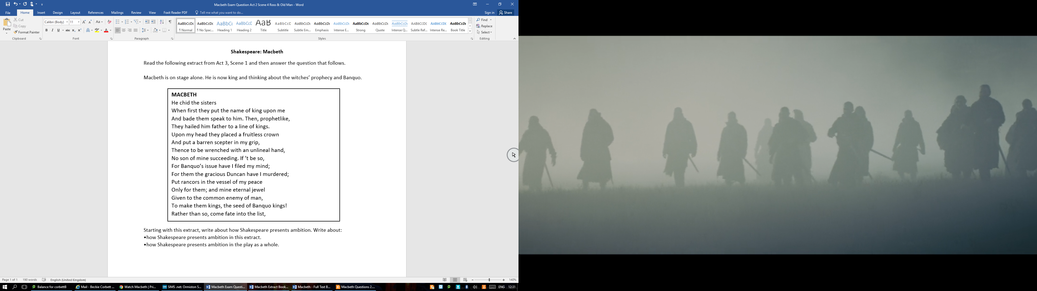

Jekyll Practice Question
Read the following extract from Chapter 5 of The Strange Case of Dr Jekyll and Mr Hyde and then answer the question that follows. In this extract, Mr Utterson goes to visit Dr Jekyll shortly after Mr Hyde has viciously murdered Sir Danvers Carew.
It was the first time that the lawyer had been received in that part of his friend’s
quarters; and he eyed the dingy, windowless structure with curiosity, and gazed
round with a distasteful sense of strangeness as he crossed the theatre, once
crowded with eager students and now lying gaunt and silent, the tables laden with
chemical apparatus, the floor strewn with crates and littered with packing straw,
and the light falling dimly through the foggy cupola. At the further end, a flight of
stairs mounted to a door covered with red baize; and through this, Mr. Utterson
was at last received into the doctor’s cabinet. It was a large room, fitted round
with glass presses, furnished, among other things, with a cheval-glass and a
business table, and looking out upon the court by three dusty windows barred with
iron. A fire burned in the grate; a lamp was set lighted on the chimney shelf, for
even in the houses the fog began to lie thickly; and there, close up to the warmth,
sat Dr. Jekyll, looking deadly sick. He did not rise to meet his visitor, but held out
a cold hand and bade him welcome in a changed voice.
‘And now,’ said Mr. Utterson, as soon as Poole had left them, ‘you have heard the
news?’
The doctor shuddered.’ They were crying it in the square,’ he said. ‘I heard them
in my dining-room.’
‘One word,’ said the lawyer. ‘Carew was my client, but so are you, and I want to
know what I am doing. You have not been mad enough to hide this fellow?’
‘Utterson, I swear to God,’ cried the doctor,’ I swear to God I will never set eyes
on him again. I bind my honour to you that I am done with him in this world. It is
all at an end. And indeed he does not want my help; you do not know him as I do;
he is safe, he is quite safe; mark my words, he will never more be heard of.’

Starting with this extract, how does Stevenson present Dr Jekyll as an isolated and confused character?
Write about:
- how Stevenson presents Dr Jekyll in the extract;
- how Stevenson presents and develops the character of Dr Jekyll in the novella as a whole.

