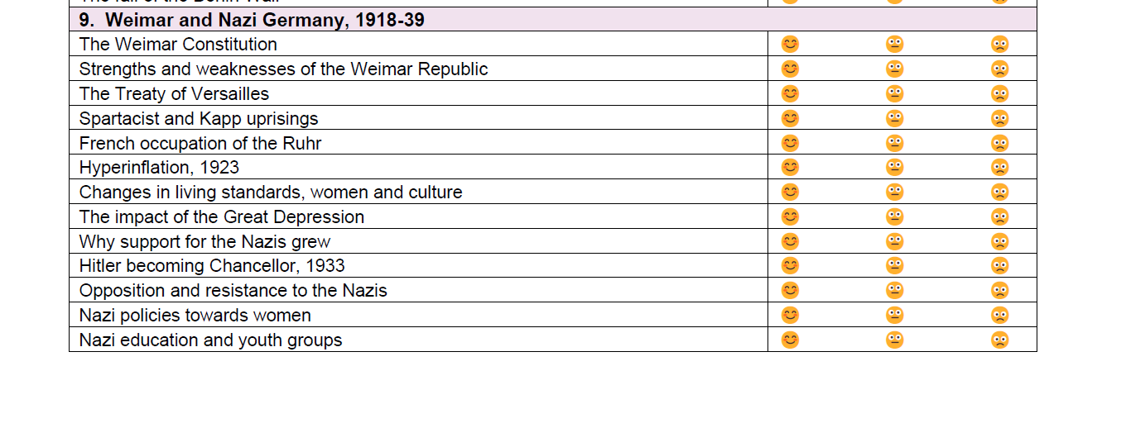
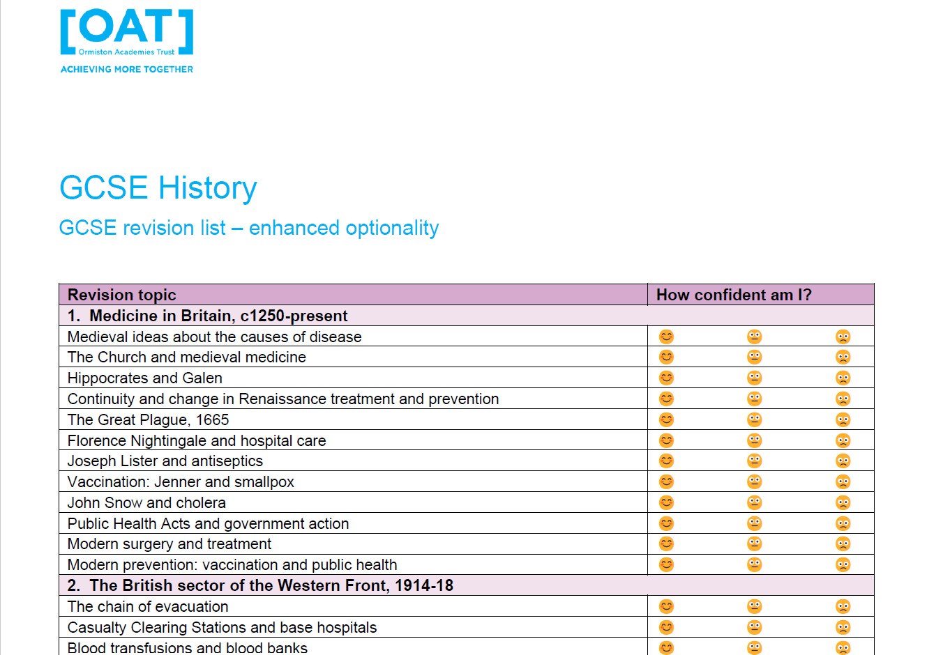
Revision support
▪ Use this list to identify the topics from the units your school has taught.
▪ Revise the knowledge, then practise exam questions and source/interpretation skills using past papers.
You may wish to use BBC Bitesize GCSE History.: Offers clear subject notes, timelines, and short test questions covering the major Edexcel topics or Seneca Learning GCSE History : Provides free interactive online revision courses tailored to the Edexcel specification, including flashcards and quizzes.

